DIPLÔME DE COMPTABILITÉ ET DE GESTION

UE 12 – ANGLAIS DES AFFAIRES

SESSION 2022

Durée de l’épreuve : 3 h 00 – Coefficient : 1

Aucun matériel (agendas, calculatrices, traductrices) ni dictionnaire n’est autorisé.

Dès que le sujet vous est remis, assurez-vous qu’il est complet.
Le sujet comporte 6 pages numérotées de 1 / 6 à 6 / 6.

DOCUMENT 1
UK EMPLOYERS STRUGGLE WITH WORST LABOUR SHORTAGE SINCE 1997
Britain’s employers are struggling with the worst staff shortages since the late 1990s, amid the rush to reopen from lockdown and a sharp drop in overseas workers due to Covid and Brexit.
Sounding the alarm over the risks to economic recovery from acute labour shortages, the Recruitment and Employment Confederation (REC) and the accountancy firm KPMG said the number of available workers plunged in June at the fastest rate since 1997.
Recruitment firms are reporting hiring challenges across several sectors of the economy, led by shortfalls in areas such as transport and logistics, hospitality, manufacturing and construction.
As well as the trouble recruiting chefs, kitchen porters, cleaners and warehouse staff recorded in previous months, the snapshot indicated that issues for employers were spreading to typically higher-paying sectors such as finance, IT, accounting and engineering. […]
Business leaders said easing post-Brexit immigration rules could help address shortages, but also called for further investment in skills and training from the government to increase the numbers of domestic candidates.
Employment experts believe people are being put off from work in certain sectors that have developed reputations for low pay and poor conditions in recent years, and that concerns over continuing high rates of Covid-19 are also having an impact.
Sustained labour shortages could lead employers to push up wages, which could in turn feed through to rising inflation if companies raise their prices to accommodate higher wage bills. However, there is debate about whether bottleneck pressures as the economy reopens from lockdown will translate into a permanently tighter jobs market.
Source : “The Guardian”, 8 July 2021.

DOCUMENT 2

TO SOLVE ITS LABOR SHORTAGE, THE UK FOOD INDUSTRY IS IMPORTING MORE WORKERS
The labor shortage in the UK is particularly apparent in its food industry. McDonald’s milkshakes, Nando’s chicken, and, potentially, Christmas turkeys are all among the items made scarce in Britain because of a lack of workers.
To alleviate the labor pressure confronting the post-Brexit industry, this weekend, the UK government said 5,000 foreign truck drivers and 5,500 poultry workers will be able to work in the UK for three months. The short-term recruitment will begin in October and last until Dec. 24.
The UK food industry relies on migrant workers. Of the 2 million European Union nationals working in the UK, about a fifth of them work in the food and beverage supply chain, according to a report from the Food and Drink Federation, an industry group. The migrant workers are particularly represented in manufacturing, shipping, and food services. Most seasonal agriculture also depends on EU workers, mainly from Bulgaria and Romania.
But the government warned that the new visas are only part of the solution. Employers must also do their part by raising wages and improving working conditions, said Grant Shapps, UK transportation secretary, in a statement.
The long-standing issues of low pay and poor working conditions of the food industry
Not all shortages are the same, wrote Alan Manning, a professor of economics at London School of Economics, in a blog. For the food industry, the problem comes down to poor pay or working conditions, which means as the industry struggles to compete for local workers, it needs to turn to the government to provide them with a source of migrant labor.
The industry says the lack of necessary skills among workers or negative perceptions of the field, rather than low pay, is to blame for the shortages. Raising pay could also lead to higher prices and reduce demand for the goods and services, Manning said. But the industry has had long-standing issues with recruitment and retention, which have been exacerbated by the pandemic.

Source : www.qz.com, 27 September 2021.

DOCUMENT 3

TIME RUNNING OUT TO SAVE UK INDUSTRY FROM WORKER SHORTAGES, SAY BUSINESS LEADERS
Worker shortages have left UK service stations empty, created gaps on supermarket shelves and are forcing farms to cull pigs. Even the finance industry is starting to suffer. The situation could get much worse this winter if the British government doesn't relax its Brexit immigration rules, business leaders say.
Farmers, bankers, retailers, transporters and restaurateurs have warned in recent weeks that tighter immigration rules put in place after Britain left the European Union are making it hard for them to find workers and keep their businesses running.
Supermarkets are struggling to keep some specific foods stocked, while McDonald's temporarily stopped serving milkshakes and Nando's ran out of its signature peri peri chicken. Meat processors can't keep up with demand, and farmers are warning that there won't be enough turkeys at Christmas. Abattoirs can't cope with the number of pigs being reared.
Banks are the latest to sound the alarm. TheCityUK, which represents the United Kingdom's huge financial services industry, said Thursday that its members were seeing "significant cost increases to securing the high-skilled talent that they need to compete on the global stage." […]
The financial sector is asking the government to make it easier for workers to come to the United Kingdom for short stints. It also wants the government to negotiate with other countries to allow workers to easily cross borders for roles with their current employer.
The scale of the challenge facing UK employers has been highlighted over the past week, when a shortage of tanker drivers forced some service stations to close. British motorists resorted to panic buying, causing widespread gasoline shortages that persisted for days.
The government responded with emergency measures that included temporary 5,000 visas for foreign truck drivers. Britain faces a much bigger shortfall of 100,000 drivers, according to industry groups, but Prime Minister Boris Johnson signaled that his government is unlikely to authorize more.
"What we want to see is an emphasis on high wage, high skill — a high productivity approach to our economy. What I don't think that people in this country want to do is fix all our problems with uncontrolled immigration," said Johnson.
Source : www.edition.cnn.com, 1 October 2021.

DOCUMENT 4

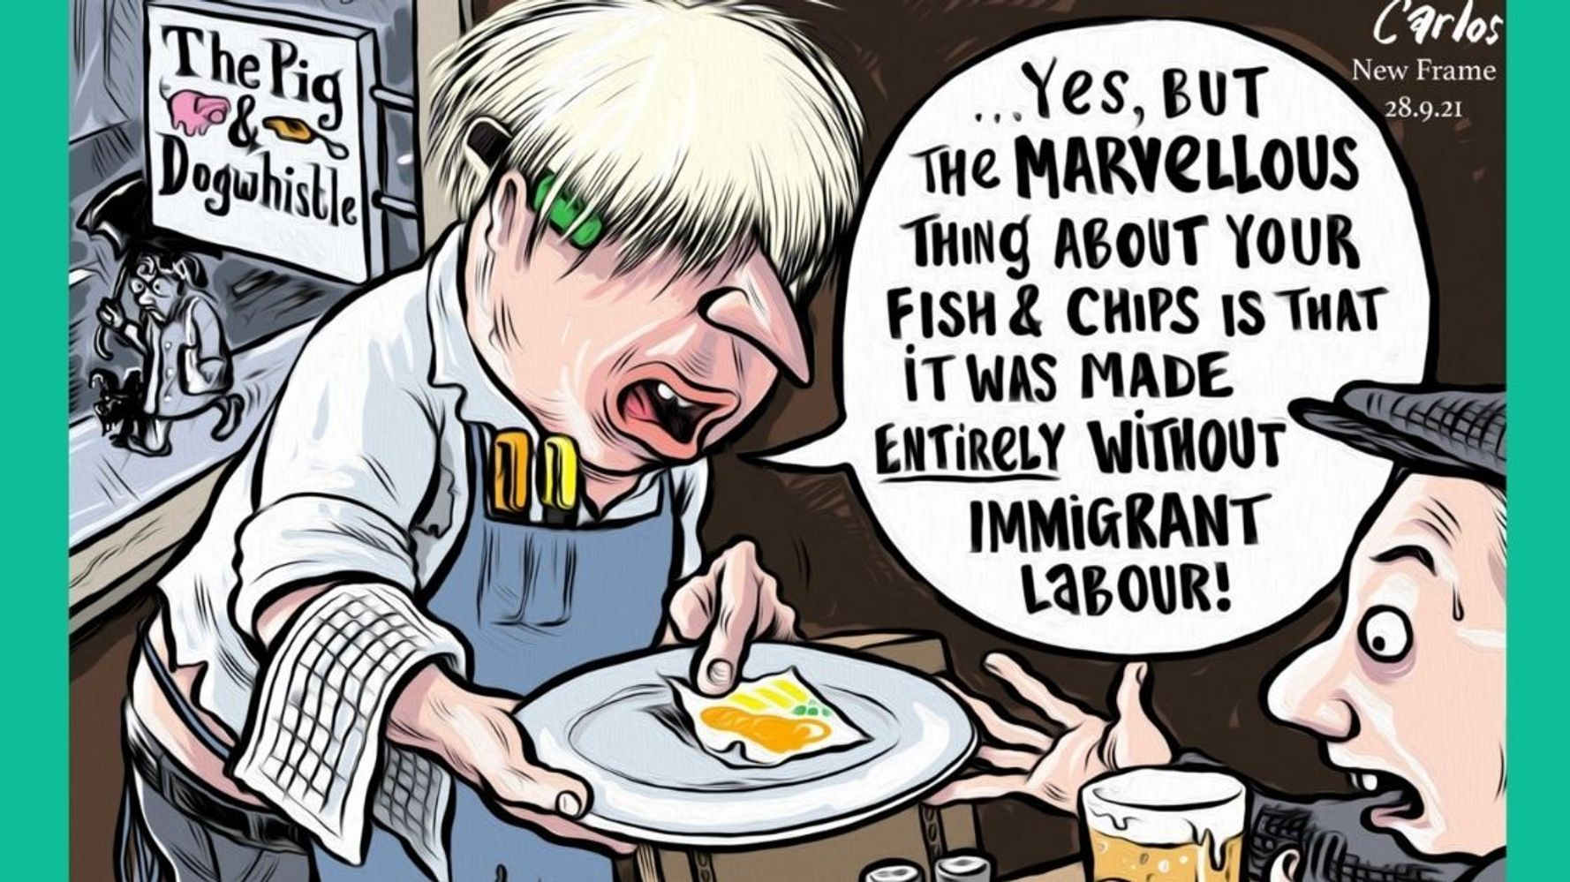

Source : by Carlos Amato, www.newframe.com, 28 September 2021.

NB : The man on the left is Boris Johnson.

Le dossier qui vous est proposé comporte 4 documents :

Document 1 : un article publié par The Guardian, le 8 juillet 2021, et intitulé « UK employers suffer from worst labour shortage since 1997. »
Document 2 : un article publié par qz.com, le 27 septembre 2021, et intitulé « To solve its labour shortage, the UK food industry is importing more workers. »
Document 3 : un article publié par edition.cnn.com, le 1 octobre 2021, et intitulé « Time running out to save UK industry from labour shortages, say business leaders. »
Document 4 : un dessin humoristique de Carlos Amato publié par newframe.com, le 28 septembre 2021.

I – COMPRÉHENSION (10 points)

En vous appuyant sur les quatre documents fournis, vous rédigerez en français une synthèse de 250 mots (+/-10 %) qui rendra compte de la problématique du dossier.
Vous indiquerez nécessairement le nombre de mots utilisés.

II – EXPRESSION EN LANGUE ANGLAISE (10 points)

- Comment on document 4
150 words (+/- 10 %).
Indicate the number of words used.

- Write a letter
Vous êtes Paul Dreschler, président de la Confederation of British Industry (CBI), le plus important syndicat patronal britannique. Rédigez une lettre officielle adressée à Rishi Sunak, ministre des finances (Chancellor of the Exchequer) afin de lui signifier les inquiétudes des entreprises quant au manque de main d’œuvre dans le pays. Vous lui ferez ensuite part de vos suggestions afin de pallier cette difficulté.
Formules et présentation d’usage.
Vous indiquerez le nombre de mots utilisés. 150 mots, (+/-10%).

Adresses :

Paul Dreschler Rishi Sunak
Confederation of British Industry HM Treasury
Cannon Place The Correspondence and Enquiry Unit
78 Cannon Street 1 Horse Guards Road
London London
EC4N 6HN SW1A 2HQ

kill

